Training Announcement

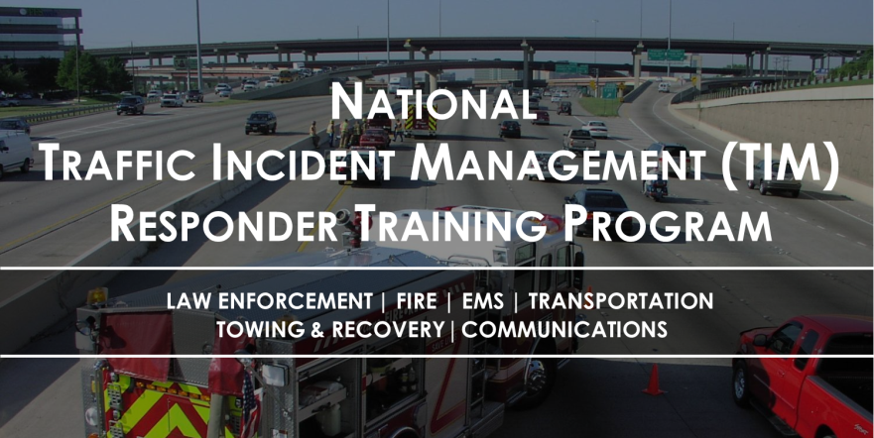
Train-the-Trainer Course

Why this is important… Responders are being struck and killed at traffic incidents in the U.S. on average:
- 5 Firefighters each year
- 1 Law Enforcement Officer each month
- 1 Tow Truck Operator each week

The National TIM Responder Training Program was developed by responders for responders, and was designed to establish the foundation for and promote consistent training of all responders to achieve the three objectives of the TIM National Unified Goal (NUG):
- Responder Safety
- Safe, Quick Clearance
- Prompt, Reliable, Interoperable Communications
The Train-the-Trainer (TtT) course is intended to provide participants (i.e., trainers) the knowledge and materials necessary for them to conduct TIM training for TIM responders in their area or state. The TtT is a 1½-day course that covers 11 hours of material, including classroom training as well as hands-on and outdoor activities. Once trainers have completed the TtT course, they will have the flexibility to train others as appropriate using either the full version of the training or through use of a condensed 4-hour version of the training.
The target audience for this course is experienced trainers from all TIM disciplines, including: Law Enforcement, Fire/Rescue, Emergency Medical Service, Towing and Recovery, Emergency Management, Communications, and Highway/Transportation.
Details for the xx TtT session are as follow:
Day 1: xx
Day 2: xx
Location: xx
Address: xx
Registration Site:

This training is being provided free of charge, however, agencies are responsible for all travel related expenses including lodging and meals.
If you have any questions regarding local TIM initiatives or your participation in this training, please contact xx at xx or via phone at (xxx) xxx-xxxx.
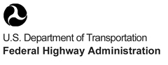
Hosted By:
This training has also been endorsed by the International Association of Chiefs of Police (IACP), the International Association of Fire Chiefs (IAFC), the American Association of State Highway and Transportation Officials (AASHTO), the National Volunteer Fire Council (NVFC), the International Association of Directors of Law Enforcement Standards and Training (IADLEST), and the Towing and Recovery Association of America (TRAA).

